

**India SDG Dashboard**

Data Manage Manual

Contents

CHAPTER 1: Introduction 3

CHAPTER 2: Login 4

CHAPTER 3: Data Summary 5

CHAPTER 4: Data Template 7

4.1: Import Area 8

4.2: Import Indicator 11

4.3: Import Default Chart Type 14

4.4: Import Data 16

4.5: Import Metadata 19

Chapter 5: Data Entry/Edit 21

Chapter 6: Data Approve/Publish 24

Chapter 7: Data Import Log 25

Chapter 8: SDMX 26

8.1: Export SDMX 27

8.2: Import SDMX 30

# CHAPTER 1: Introduction

This user guide is developed for the users to understand and use the **Data manager** application of India SDG Dashboard. The data manager is a web application that can be accessed by a web browser and requires an internet connection. This application has a user restriction and can be accessed after your login. Only the system administrator and the users with login and password can access this application. The Data Manager application comprises of the following modules:

* 1. Data Summary
  2. Data Template
  3. Data Entry/Edit
  4. Data Approve/Publish
  5. Log
  6. SDMX

In the following chapters, we will understand and learn how to use each module.

# CHAPTER 2: Login

Type the URL <https://itmcloud.org/india-sdg/datamanager/login> in the web browser. You will land on the login page of the application as shown in the below figure.

Log in to the application using the Email id and Password. After this, you have to enter the captcha to login. Once, you enter the correct captcha your Login button gets enabled. Click on the Login in button to enter in the data manager application.

# CHAPTER 3: Data Summary

The first page after a successful login is Data Summary (see below figure).

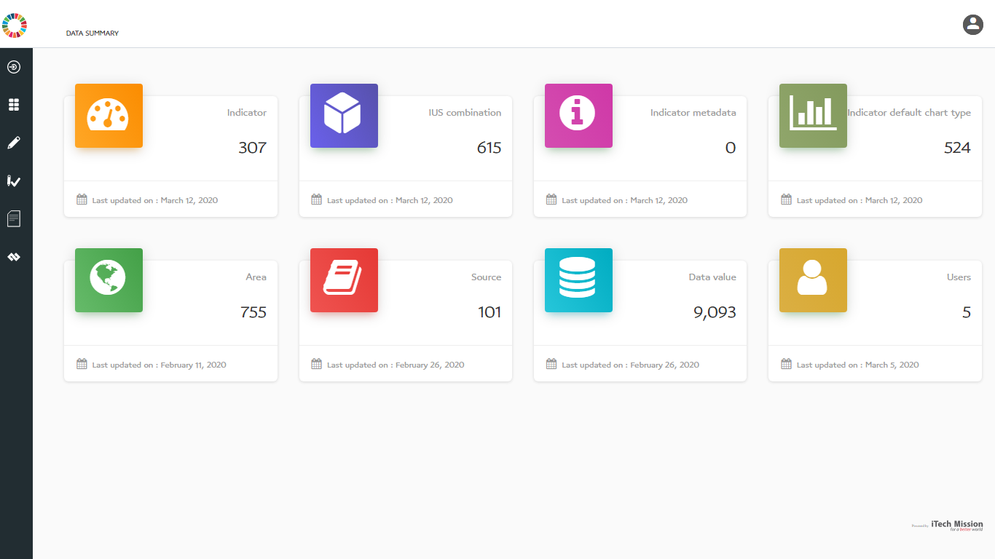

This data summary shows the following information:

1. **Indicator** box shows the total number of indicators available in the database and the last date/time when the list was imported.
2. **IUS Combination** box shows the total number of Indicator-Unit-Subgroup available in the database and the last date/time when the list was imported.
3. **Indicator Metadata** box shows the total number of indicator metadata are available in the database and the last date/time when the list was imported.
4. **Indicator Default type** box shows the total number of default type indicator are available in the database and the last date/time when the list was imported.
5. **Area** box shows the total number of geographical areas available in the database and the last date/time when the list was imported. The geographical areas include the state and its districts.
6. **Source** box shows the total number of data sources imported in the database and the last date/time when the list was updated. For each of the data, values and imported data source is mandatory and will be imported along with the data value.
7. **Data Value** box shows the total number of data points imported in the database and the last date/time when the data values were imported. Data values also correspond to the data records of the database.
8. **Users** box shows the total number of users been created in the application and the last date/time when the user’s list was updated.

# CHAPTER 4: Data Template

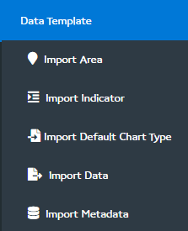The first module of this application is the data template. When you click on the data template icon from the left panel, you can see a list of sub-modules.

Let us learn how to use these sub-modules in this chapter.

## 4.1: Import Area

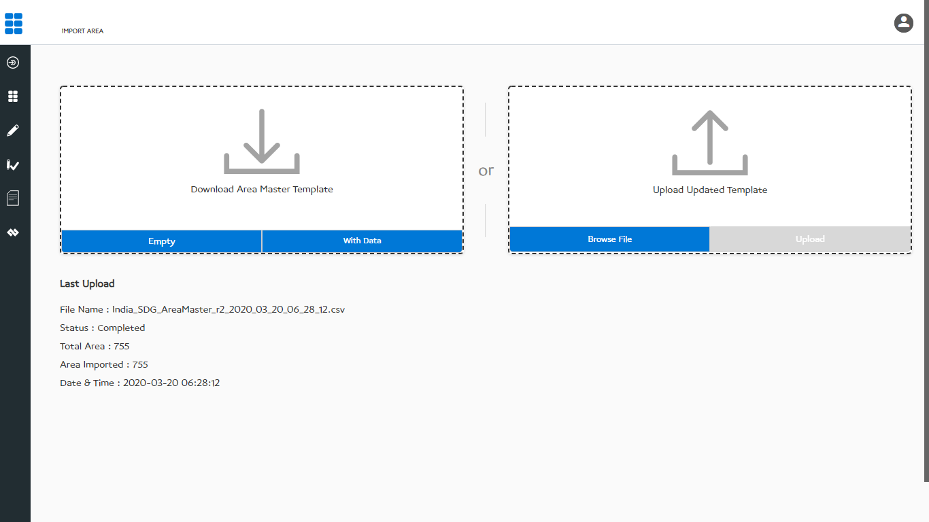Click on the import area option available under the data template module so that one can import the area into the database. You can see the figure below that has the options to download the area template, area list available in the database, and upload & import the area list into the database.

You can use this option to create an area structure that you want in the system. Below is the area structure that you can find in the area template.

|  |  |
| --- | --- |
| **AreaID** | A unique area identification that associates the area to its map. |
| **AreaName** | Area Name assigned to an area. |
| **AreaLevel** | The level number assigned in the area hierarchy. |
| **AreaParentID** | AreaID of the parent area. |
| **AreaGroup** | Group of areas other than the parent. |

You will find the two sections on this page, the download and the upload section. The download section has an option to download an empty area template and also to download the area list from the database in the area template format. CSV (Comma Separated Value) file format is used to import data in the system.

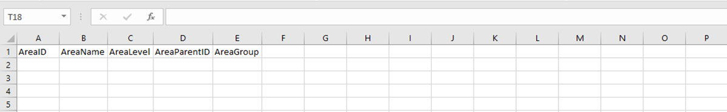Click on the **Empty** button to download the empty area template as shown in the figure below.

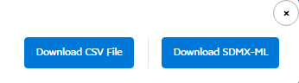Click on the `**With Data**` button to download the area list that is imported into the database. You can export the area list in CSV format or XML format (SDMX based) as shown in the below figure.

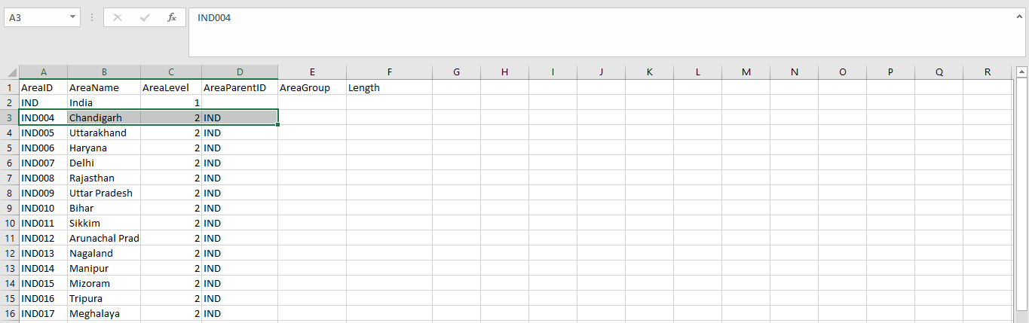The following figure shows the area data exported in CSV format.

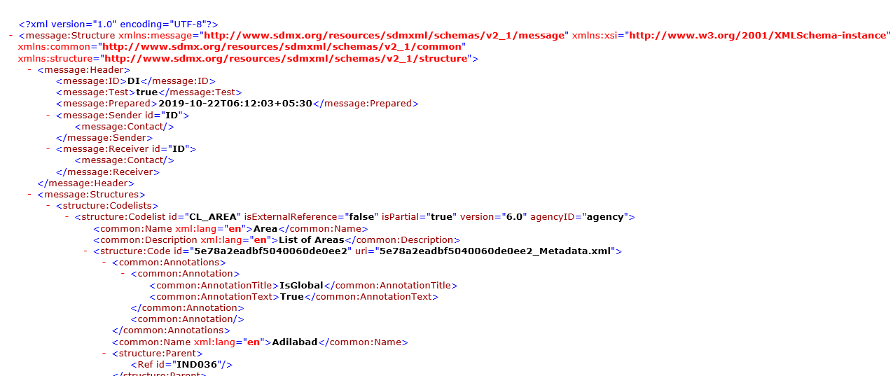Below figure shows the area data exported in SDMX-ML format.

To upload the area data into the database first enter the area hierarchy as explained above and then click on the**Browse** button to browse the area template with data and then click on the **Upload** button to start the import process. During the import process, the template is checked for blank entries, entries with special characters and duplicate entries, all these entries are not imported into the system.

The last uploaded summary will provide the details of the import process.

## 4.2: Import Indicator

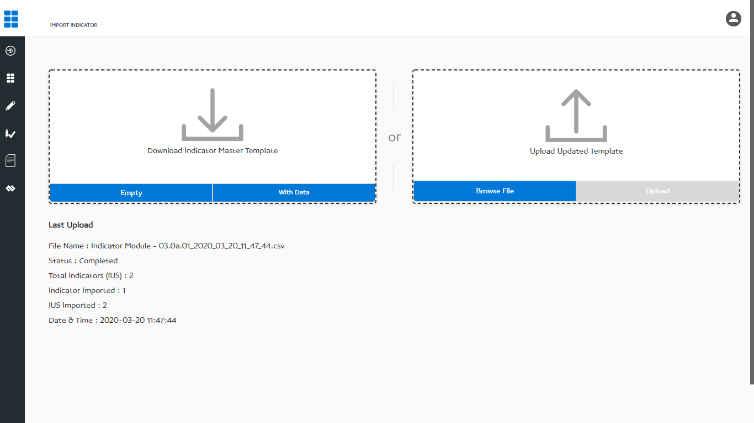Click on the import indicator option available under the data template module to import indicators into the database. You can see the below figure that has an option to download the indicator template, indicator list available in the database and upload & import the indicator list into the database.

You can use this option to create an indicator structure that you want in the system. Below is the indicator structure that you can find in the indicator template.

|  |  |
| --- | --- |
| **Sector and Subsector** | Indicator classification by Sector and Subsector |
| **Goal and Target** | Indicator classification by Goal (optional) |
| **Indicator** | Name assigned to an indicator |
| **Unit** | The measurement unit of indicator |
| **Subgroup Dimension** | Indicator disaggregation category |
| **Subgroup** | Indicator disaggregation |
| **Subgroup Order** | Indicator disaggregation sequence |
| **HighIsGood** | Status to represent the good or bad indicator |
| **IsDefaultSubgroup** | Mark one of the disaggregation as default |

You will find the two sections on this page, the download and the upload section. The download section has the option to download an empty indicator template and also to download the indicator list from the database in the indicator template format. CSV (Comma Separated Value) file format is used to import indicators in the system.

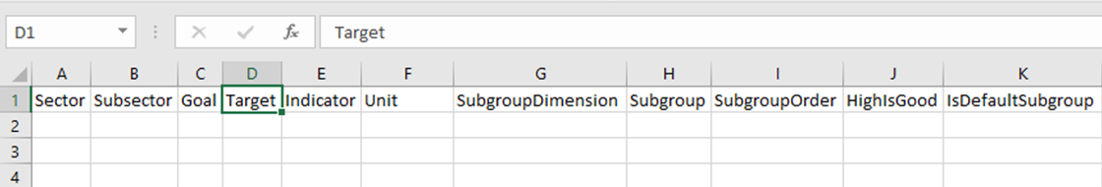Click on the **Empty** button to download the empty indicator template as shown in the figure below.

Click on the `**With Data**` button to download the area list that is imported into the database. You can export the area list in CSV format or XML format (SDMX based) as shown in the below figure.

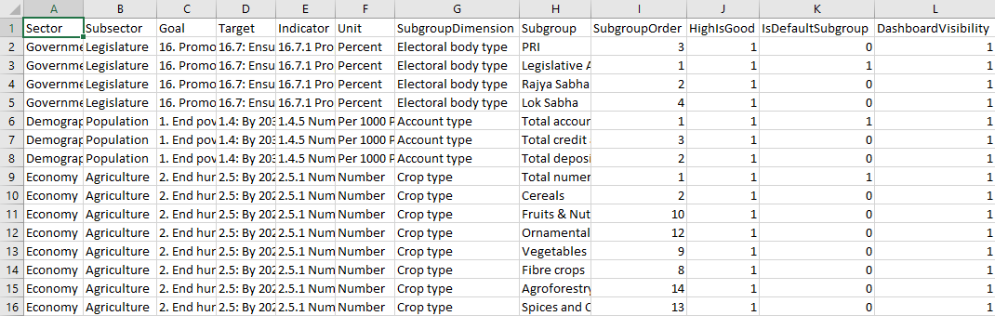The following figure shows the area data exported in CSV format.

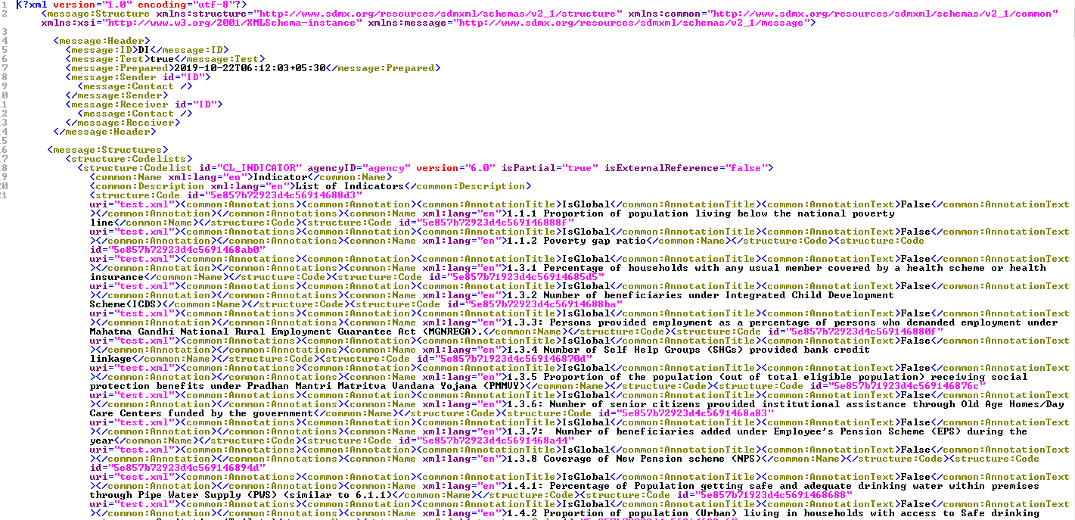Below figure shows the area data exported in SDMX-ML format.

To upload the indicator data into the database, enter the indicator details in the structure as explained above. Click on **the Browse** button to browse the indicator template with data and then click on the **Upload** button to start the import process. During the import process, the template is checked for blank entries, entries with special characters and duplicate entries. All these entries are not imported into the system.

The last upload summary provides the details of the import process.

## 4.3: Import Default Chart Type

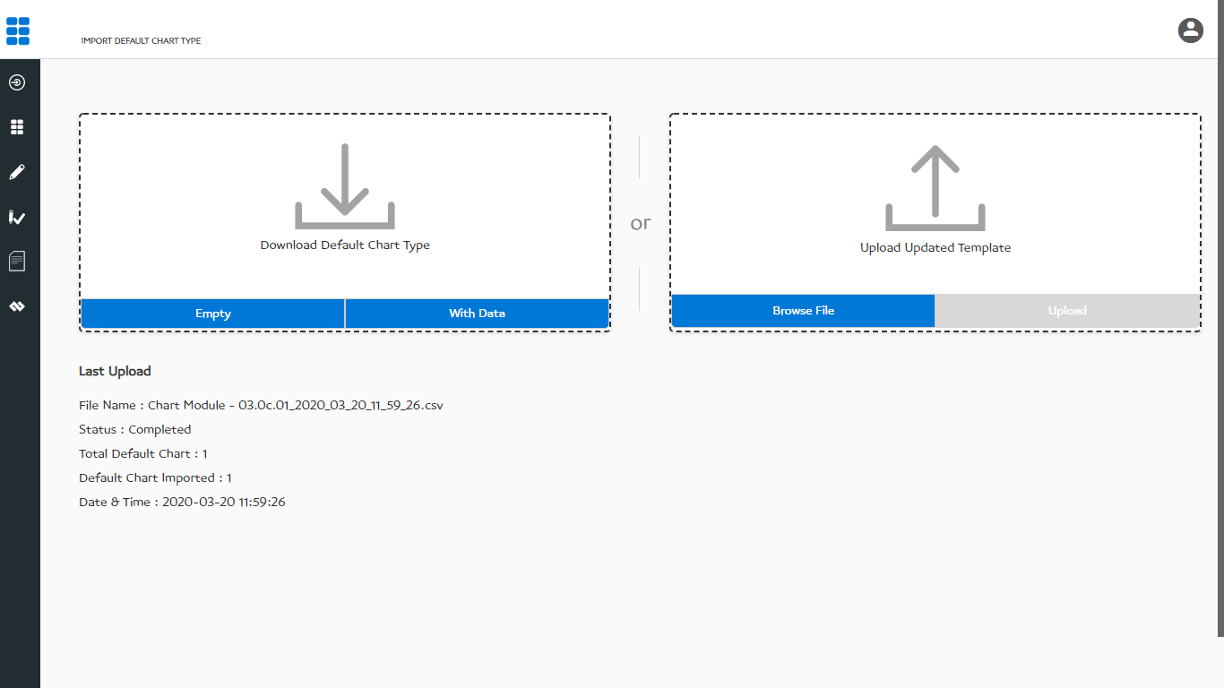Click on the import default chart type option available under the data template module to import default charts into the database. You can see the below figure that has an option to download the default chart type template and default chart list. This is available in the database and then you can upload & import the new list into the database.

You can use this option to create a default chart structure that you want in the system. Below is the default chart type structure that you can find in its template.

|  |  |
| --- | --- |
| **Sector and Subsector** | Indicator classification by Sector and Subsector |
| **Goal and Target** | Indicator classification by Goal (optional) |
| **Indicator** | Name assigned to an indicator |
| **Unit** | The measurement unit of indicator |
| **Subgroup Dimension** | Indicator disaggregation category |
| **Subgroup** | Indicator disaggregation |
| **GraphLevel** | Chart Graph level |
| **TimePeriod** | Data reporting duration (Year, Month, Day) |
| **ChartType** | Type of the default chart |

You will find the two sections on this page, the download and the upload section. The download section has an option to download an empty default chart type template and also to download the default chart type list from the database in the respective template format. CSV (Comma Separated Value) file format is used to import default chart types in the system.

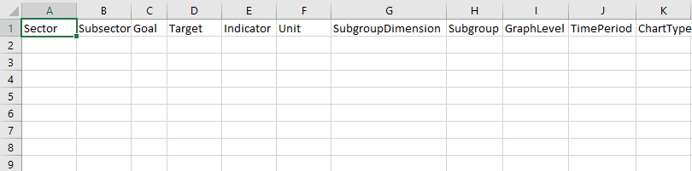Click on the **Empty** button to download the empty default chart type template as shown in the figure below.

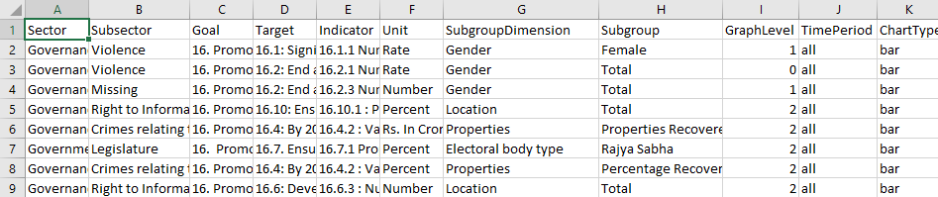Click on the `**With Data**` button to download the default chart type list that is imported into the database. The following figure shows the default chart type data that you can enter into the respective template.

To upload the default chart type data into the database first enter the default chart type structure as explained above. Click on**the Browse** button to browse the default chart type template with data. Click on the **Upload** button to start the import process. During the import process, the template is checked for blank entries and entries with special characters or duplicate entries. All these entries are not imported into the system.

The last upload summary provides the details of the import process.

## 4.4: Import Data

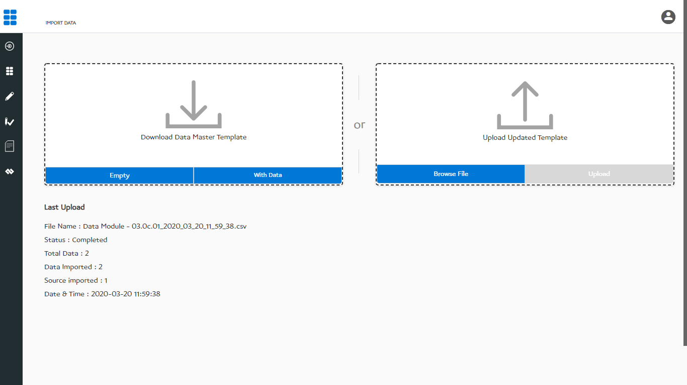Click on the import data options available under the data management modules to import data into the database. You can see the below figure that has an option to download the data template, data records available in the database, upload and import the data into the database.

You can use this option to import data into the system. Below is the data structure that you can find in the data template.

|  |  |
| --- | --- |
| **Area ID** | A unique area identification that associates the area to its map |
| **Area Name** | Area Name assigned to a geographical area |
| **Time Period** | Data reporting duration (Year, Month, Day) |
| **Source** | Data source in which data is reported |
| **Sector and Subsector** | Indicator classification by Sector and Subsector |
| **Goal and Target** | Indicator classification by Goal (optional) |
| **Indicator** | Name assigned to an indicator |
| **Unit** | The measurement unit of indicator |
| **Subgroup** | Indicator disaggregation |
| **Data value** | Actual data |
| **Footnote** | Special comment on data value |

You will find the two sections on this page, the download and upload section. The download section has the option to download an empty data template and also to download the data from the database in the data template format. CSV (Comma Separated Value) file format is used to import data in the system.

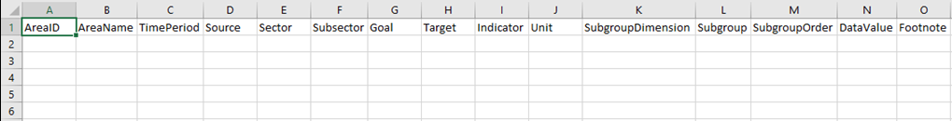Click on the **Empty** button to download the empty data template as shown in the figure below.

Click on the `**With Data**` button to download the data that is imported into the database. You can export the data in CSV format or XML format (SDMX based) as shown in the below figure.

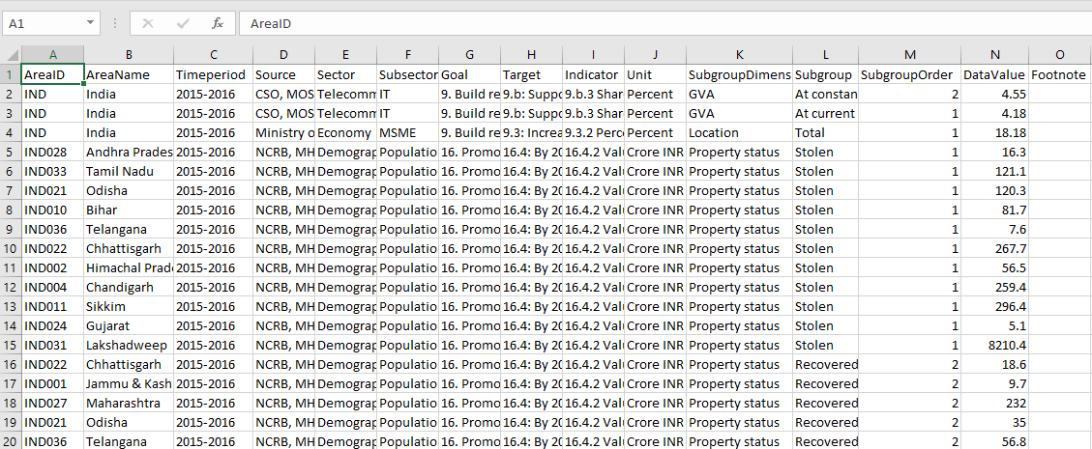 The following figure shows the area data exported in CSV format.

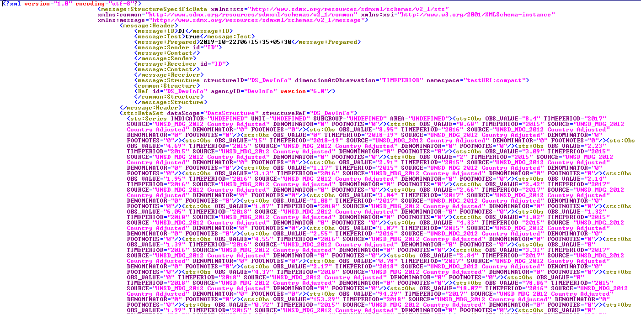Below figure shows the area data exported in SDMX-ML format.

To upload the data into the database first enter the data structure as explained above. Click on **the Browse** button to browse the data template with data and then click on the **Upload** button to start the import process. During the import process, the template is checked for blank entries, entries with special characters and duplicate entries. All these kinds of entries are not imported into the system.

The last upload summary provides the details of the import process.

## 4.5: Import Metadata

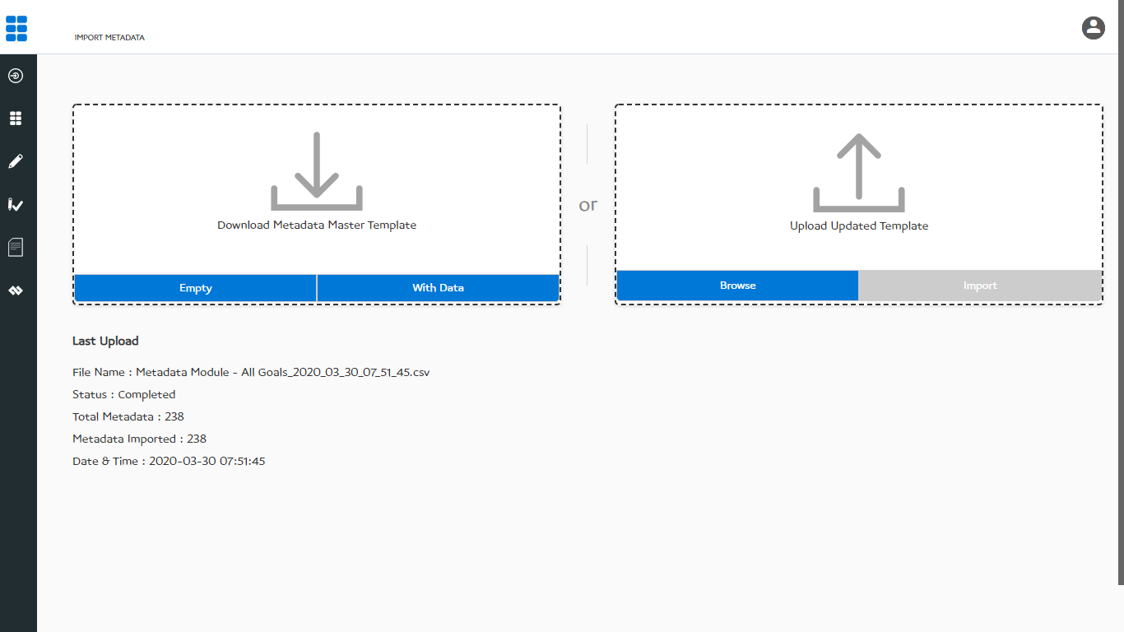Click on the import metadata option available under the data management module to import metadata into the database. You can see the below figure that has an option to download the metadata template, metadata records available in the database, upload and import the metadata into the database.

You can use this option to import metadata into the system. Below is the metadata structure that you can find in the metadata template.

|  |  |
| --- | --- |
| **Indicator** | Name assigned to an indicator |
| **Unit** | The measurement unit of indicator |
| **MT1** | Indicator Definition |
| **MT2** | Method of Computation |
| **MT3** | Overview |
| **MT4** | Comments and Limitations |
| **MT5** | Data Collection for Global Monitoring |
| **MT6** | Obtaining Data |
| **MT7** | Data Availability |
| **MT8** | Treatment of Missing Values |
| **MT9** | Regional and Global Estimates |

You will find the two sections on this window- Download and upload section. The download section has the option to download an empty metadata template and also to download the metadata from the database in the metadata template format. CSV (Comma Separated Value) file format is used to import metadata in the system.

Click on the **Empty** button to download the empty metadata template as shown in the figure below.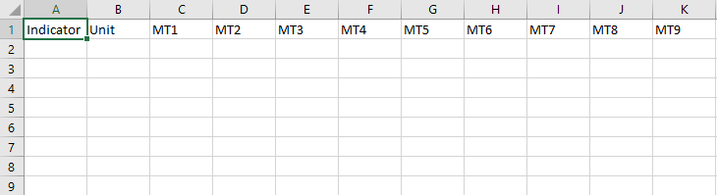

Click on the `**With Data**` button to download the metadata that is imported into the database. The following figure shows the metadata that you can enter into the metadata template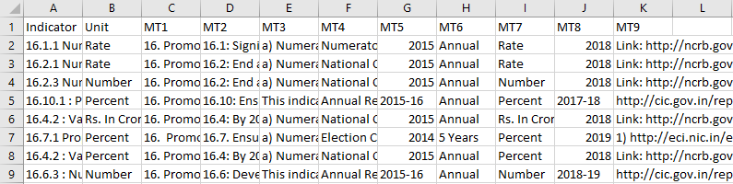

To upload the metadata into the database you need to first enter the metadata structure as explained above. Click on the **Browse** button to browse the metadata template with data and then click on the **Upload** button to start the import process. During the import process, the template is checked for blank entries, entries with special characters and duplicate entries. All these kinds of entries are not imported into the system.

The last upload summary provides the details of the import process.

# Chapter 5: Data Entry/Edit

This module allows to view and manage the underlying data in the database. The following options are available in the data entry/edit module:

* The data view is presented in a data grid.
* The data is shown by pages with an option to set the number of data rows per page.
* You can search for records by a keyword or sort them on any column.
* One, selected, or all the data records can be deleted from the database.
* Present data can be edited and replaced by the new data.

Click on the **data entry/edit** module available in the left panel, you will land on the data entry/edit page where import, export, add, edit, delete selected, delete all and search icons appear along with the list of the data available in the database. The administrator has the option to manage data through deleting and editing the available data values, sorting the data list and adding new data values in the database. By default, you can view 10 entries on one page.

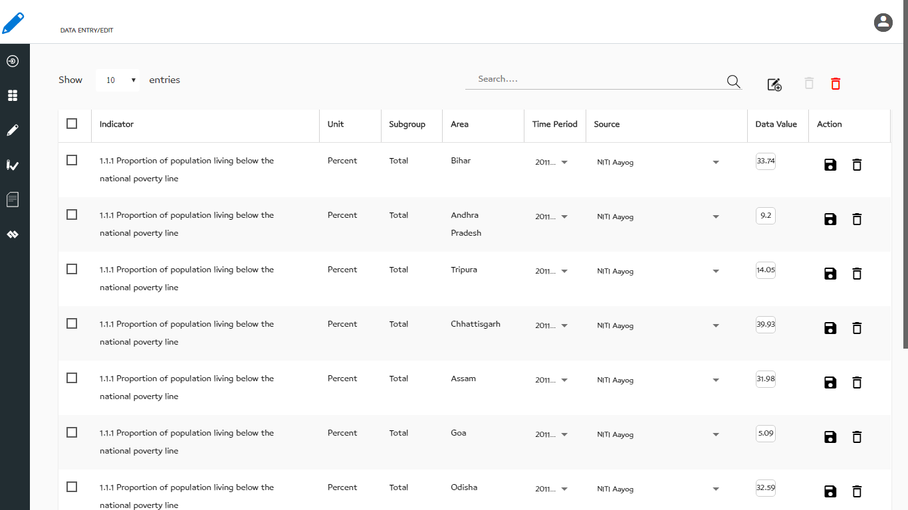You can delete one or more data values by selecting the records and clicking on the delete button. You can also delete all records in one step by clicking on the delete button.

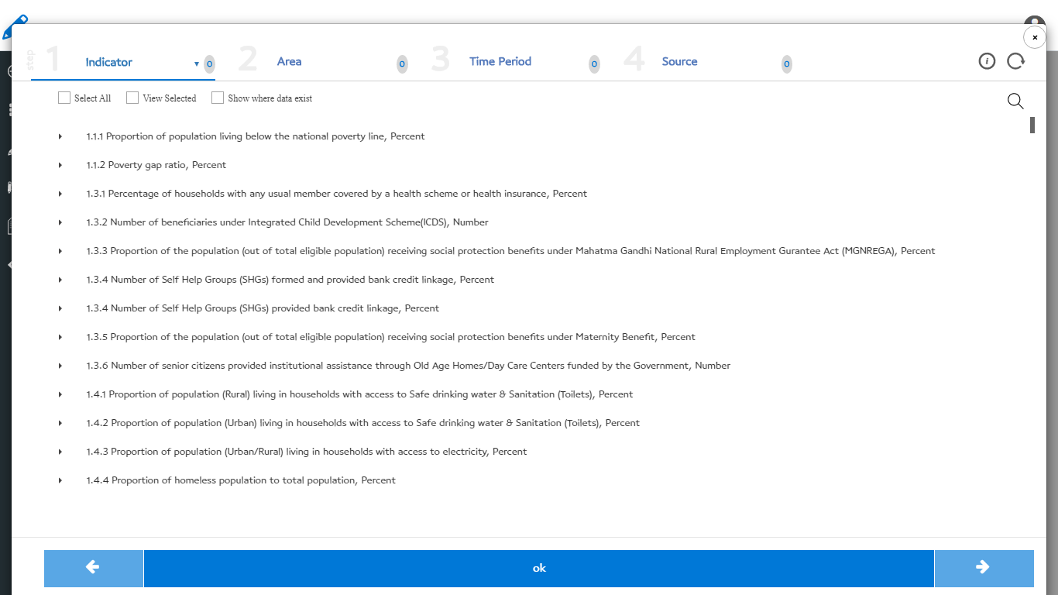Click on the add/edit data button to select the data set where you want to enter the data (see below figure). The window shows the data elements (indicator, area, time period, source) and you select them to create the data grid for which you want to enter data. The window has four tabs on top, one for each data element – Indicator, Area, Time Period, Source. On the right side of the four tabs, you will find the information button to view the selected elements and Refresh button to reinitialize the selection.

You can navigate to each of the four tabs and select the data elements for which you want to enter the data. Below let us understand how to use each tab:

**Indicator:** This tab allows you to navigate through the indicators list available in a list view (alphabetically arranged) or you can view them by their respective sectors. You can select single or multiple IUS (Indicator – Unit – Subgroup) combinations.

**Area:** This tab allows navigating through the area hierarchy. You can select one or more areas for which you want to search the data.

**Time Period:** This tab allows viewing all the time period present in the database. You can select one or more time periods for which you want to enter the data.

**Source:** This tab allows you to view all the sources present in the database. You can select one of the sources for which you want to enter the data.

In each of the tabs, there is an option to “Select All” the elements, View the selected elements and also switch on/off the elements against which the data is available in the database.

After selecting the elements – Indicator(s), Area(s), Time Period(s), Source(s) click on the click on “ok” to enter the data.

# Chapter 6: Data Approve/Publish

The data entered/imported into the database has to be verified and published. Only published data will show on the dashboard. The Data Approve/Publish module allow you to publish the data on the dashboard. Select this sub-module from the left panel. On the data approve/publish page (see below figure) you will see only those data that are pending for approval and to get published. You can search the indicators or sort the data grid on a specific column. The user can click on the publish button to publish data.

The administrator has various options on this page:

* Sort the data grid and view the data by pages
* Search for a specific record
* Publish selected data by filtering the data using the data filter button. The filter button opens a window to select the indicator – area – time period – source for which the data needs to be published. The functionality of the filter window is the same as the add/edit option of Data Entry/Edit explained in Chapter 5.
* 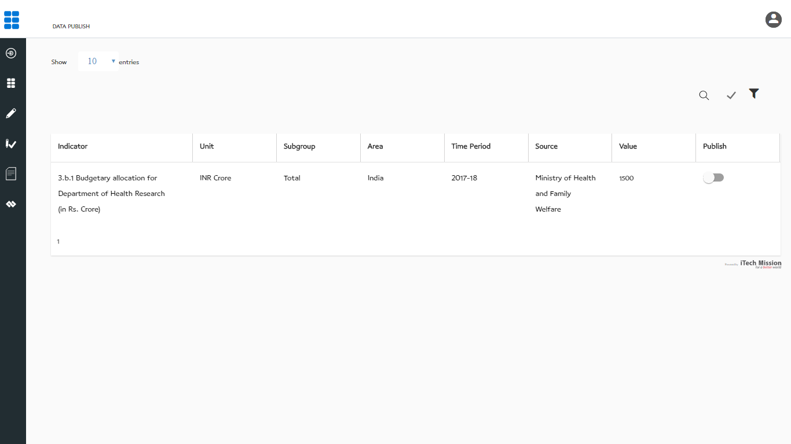Publish all data using the publish all button

# Chapter 7: Data Import Log

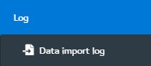Each time the data is imported into the database a log is generated. The data import log available in the left panel allows to access the log. Click on data import log option as shown in below figure.

The Log management window (see below figure) shows the list of all the import logs along with the log summary that includes: Number of records imported successfully, records updated, records with errors, the total number of records processed, date/time of the import process and a download icon to download the log on your local system. This log file is download in .csv format.

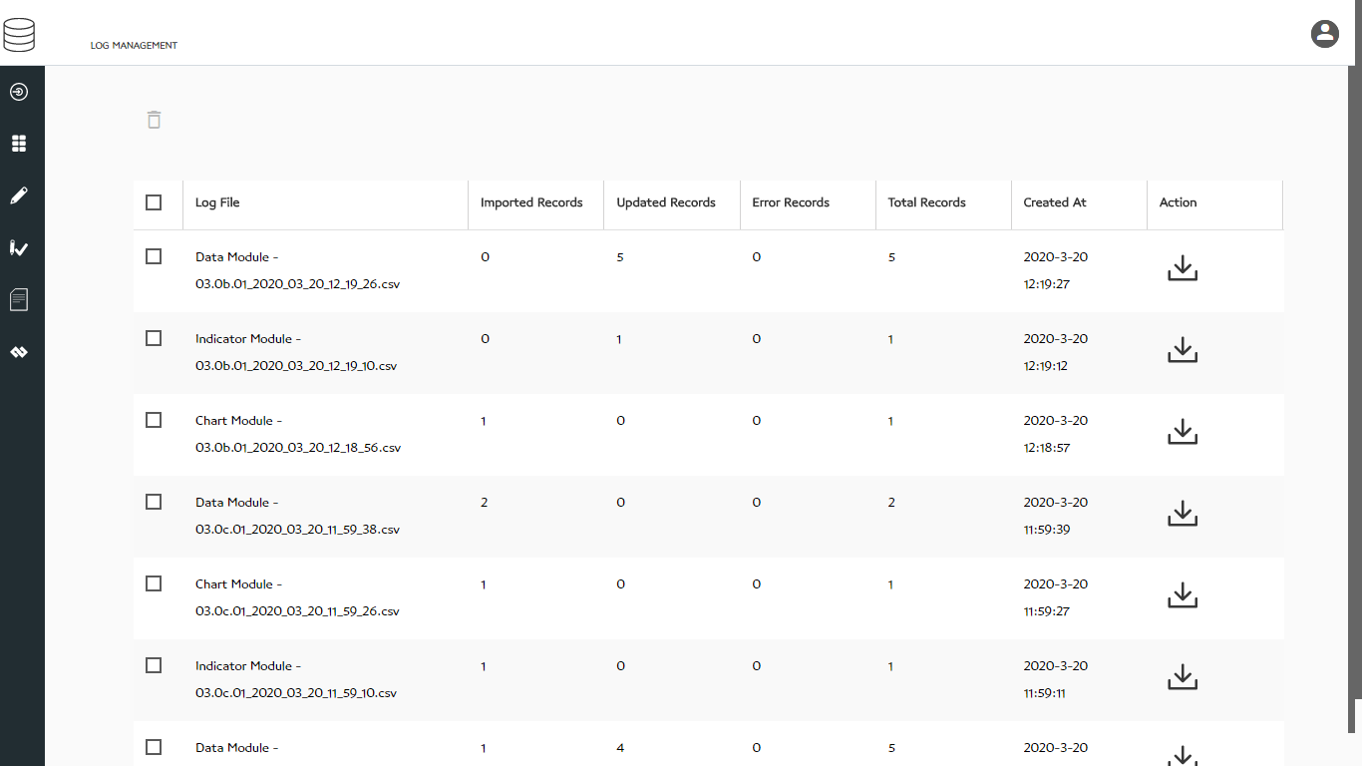You can delete the logs if they are not required. Select the logs that you want to delete and click on the delete button.

# Chapter 8: SDMX

SDMX (Statistical Data and Metadata Exchange) are the open-source data exchange standards to allow seamless exchange of data among the applications that can produce and consume data in SDMX formatted data files. The India SDG Dashboard data structure is SDMX complaint. It follows the standards suggested by SDMX. All data elements of the database are recorded with their standard unique IDs.

The data structure is formed by the data elements – Area, Indicator, Unit, Subgroup dimension, Subgroup, IUS, Time Period, Source. All these data elements are assigned unique IDs when recorded in the database. Data Structure Definition (DSD) is the collection of all the data elements and their unique IDs. An implementing agency can have complete control of the codification of the data elements.

This SDMX module allows you to export the data elements from the database as individual code lists or as Data Structure Definition. These files are exported in the XML format (an open-source web data format). The codes can be managed/edited in these XML files outside the system and imported back into the database to set the codes as agreed between implementing agency and the other partners (data providers and data subscribers).

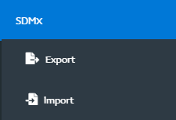The SDMX module from the left panel has two sub-modules – Export and Import as shown in the below figure.

Let us learn how to use these sub-modules in this chapter.

## 8.1: Export SDMX

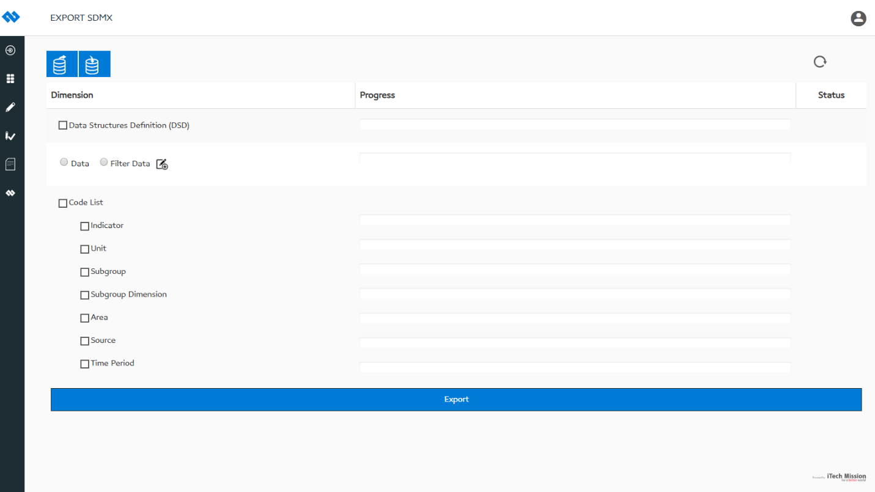Click on the Export option available under the SDMX module to open this sub-module. The export SDMX sub-module allows you to export the data elements and data into the SDMX formatted XML files. SDMX compliance suggests to package the data with the sender and receiver’s detail. The two buttons on top allow you to enter the sender and receiver’s detail. You have the option to select and to export the complete Data Structure Definition (DSD), complete data set, selected data set and separate code lists – Indicator, Unit, Subgroup Dimension, Subgroup, Area, Source, Time Period. Select what you want to export into SDMX formatted XML files and then click on the Export button to start the export process (see below figure).

You can enter the sender and receiver details by clicking on the buttons present on top. Below figures show the details that you can enter for the sender and the receiver of the data.

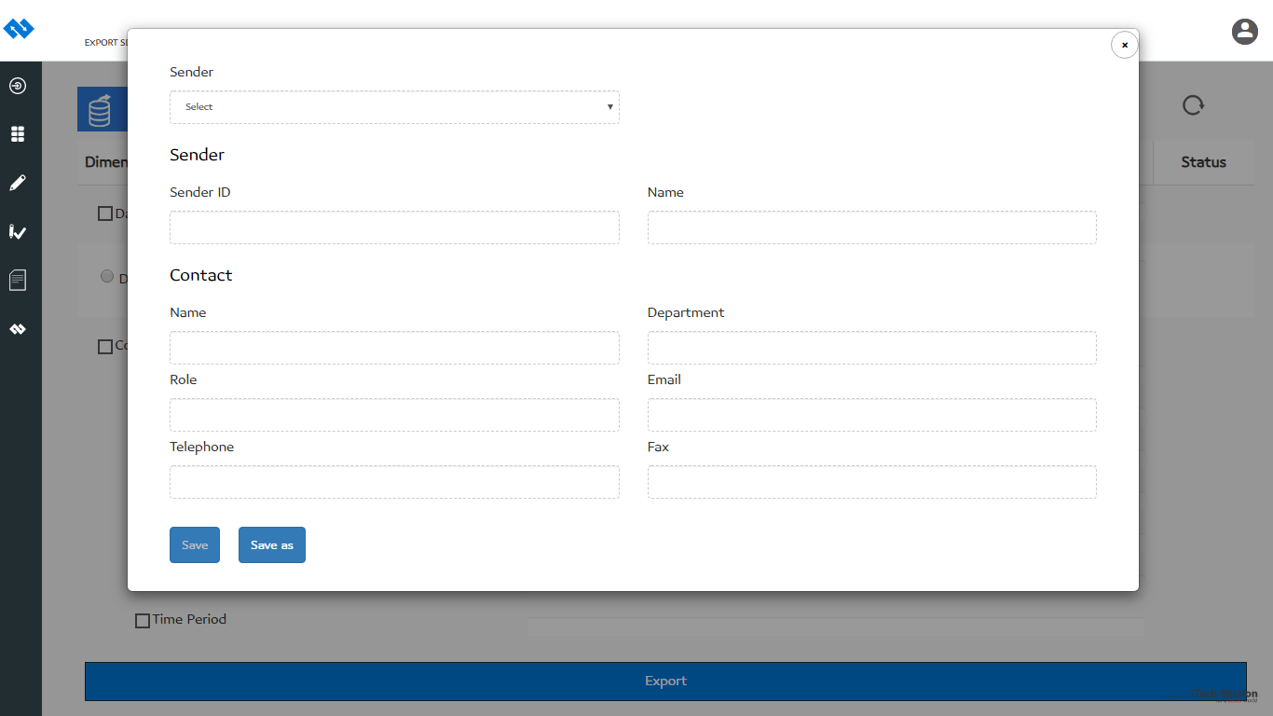Enter sender details as shown below.

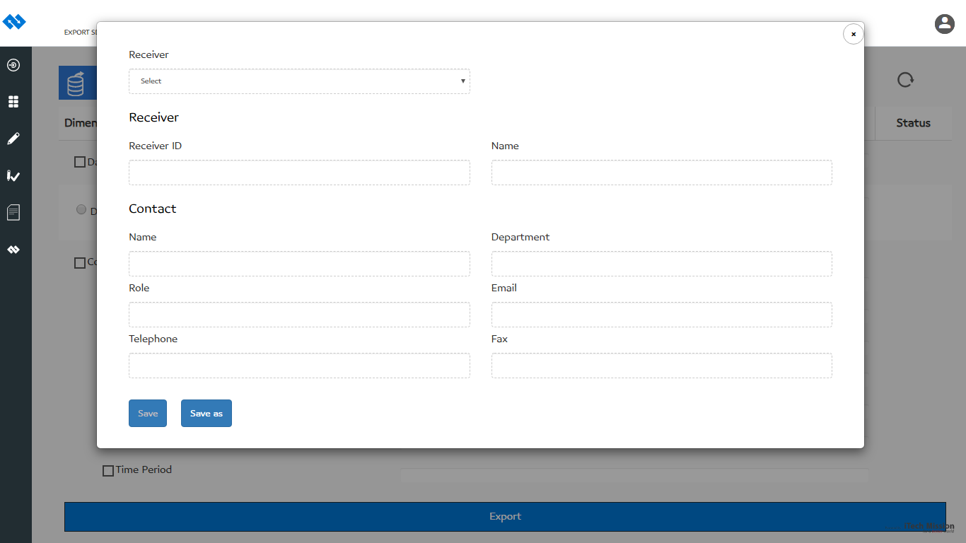Enter received details as shown below.

If you want to export the selected data, select the Filter Data option and click on the filter button. The window pops open and allows you to select the indicator – area – time period – source for which you want to select the data and export. The functionality of the filter window is the same as the add/edit option of Data Entry/Edit explained in the above Chapter 5.

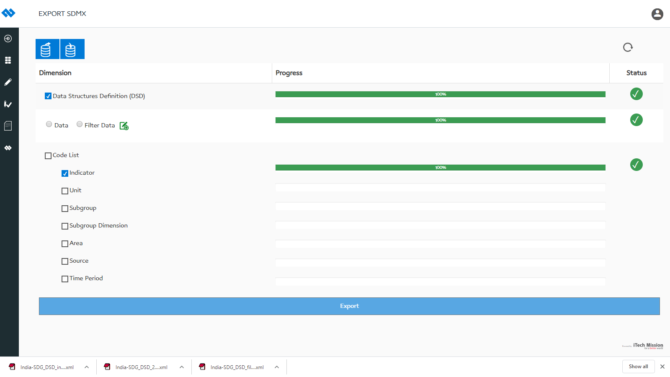Below figure show the status of the export process after the export is successfully completed.

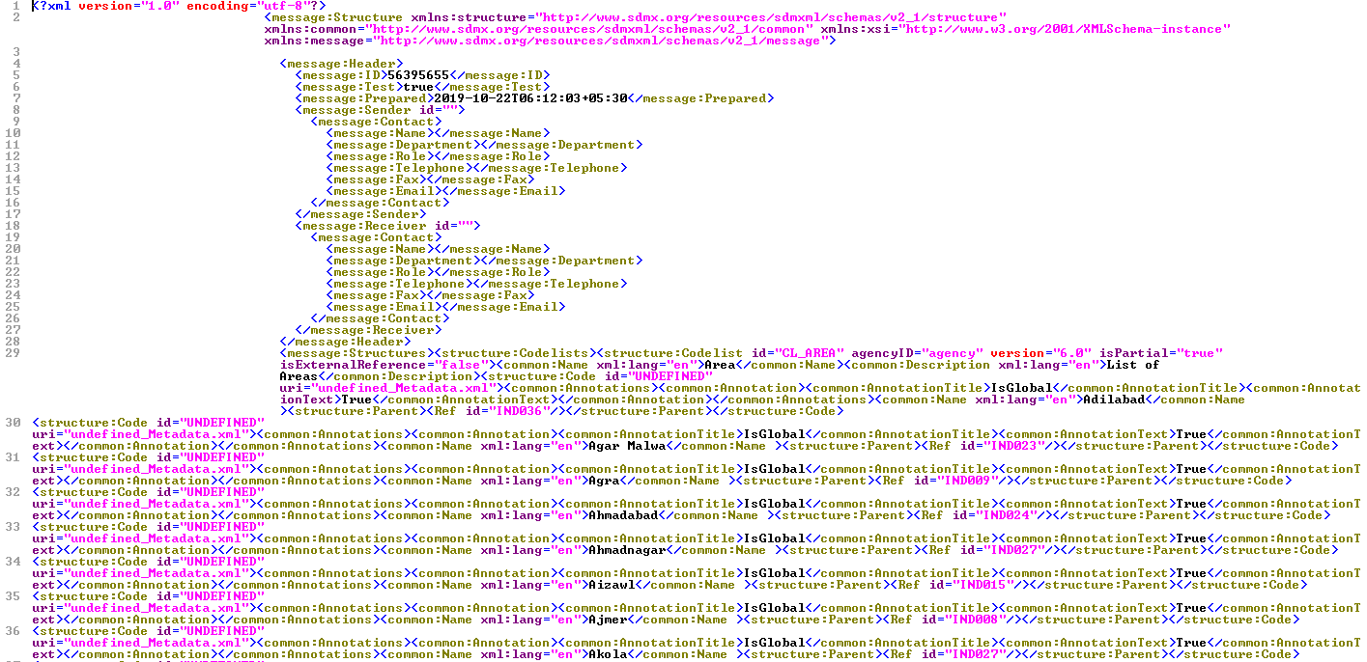Below is the Exported DSD in SDMX formatted XML format.

## 8.2: Import SDMX

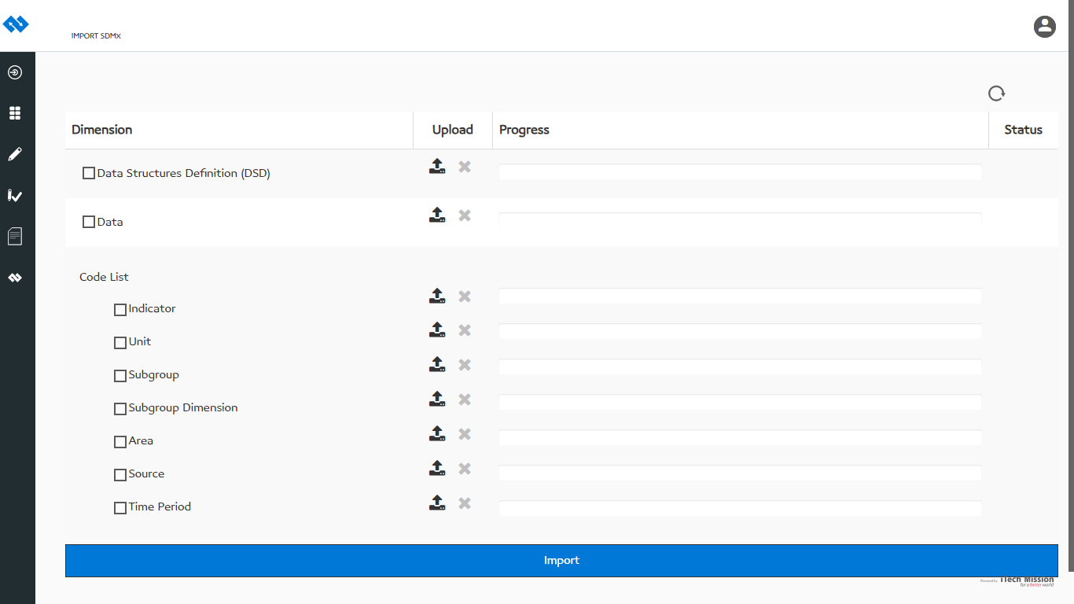Click on the Import option available under the SDMX module to open this sub-module. The import SDMX sub-module allows you to import the data elements and data from the SDMX formatted XML files into the underlying dashboard database (look at the figure below).

Click on the upload button to browse and load the SDMX formatted XML files of DSD, data and code lists that you want to import into the database. All the features of Import SDMX are the same as explained in the Export SDMX option.

----End of the document ----